|  |
| --- |
| **SKIN CARE ANALYSIS AND RECOMMENDATION SYSTEM** |

**Team members:**

**S.Syed Harshath - 2023510045**

**R.Harish - 2023510306**

**C.Barath - 2023510308**

**T.Balamurugan - 2023510309**

1. **Introduction :**

Skincare is an essential aspect of personal health and wellness. With increasing exposure to pollution, stress, and poor dietary habits, skin-related issues have become more prevalent. Identifying one's skin type and specific problems such as acne or wrinkles plays a crucial role in recommending effective skincare routines. This project aims to build an automated skincare recommendation system that takes an image as input and classifies the user's skin type, acne level, and presence of wrinkles using traditional machine learning techniques. Additionally, lifestyle data is incorporated to generate personalized product-agnostic skincare tips.

1. **Why i Chose This Project? : Societal Impact**

This project was chosen due to the growing concern around skincare and the lack of affordable, accessible, and personalized tools. Most available solutions are either product - centric or require dermatological consultations. By automating this process using open-source tools, we aim to democratize skincare access for individuals, especially in rural or underserved areas, providing guidance without commercial bias.

1. **Methodology :**

The proposed skincare recommendation system consists of three primary classification tasks: detecting skin type, acne, and wrinkles from facial images. The methodology uses a hybrid machine learning approach, combining traditional feature-based techniques with deep learning (CNN) for enhanced accuracy in acne detection. Final personalized skincare advice is generated using both image analysis and lifestyle inputs.

**Step-by-Step Workflow:**

1. **Image Input & Preprocessing:**

* Users upload a facial image, which is resized to 128x128 pixels.
* The image is converted to grayscale for texture-based features.
* Histogram equalization is applied to enhance contrast for better feature detection.
* For CNN-based acne detection, the RGB image is normalized and resized to 224x224 (for VGG16).

1. **Feature Extraction:**

Feature extraction depends on the classification task:

* Skin Type:

Color Histogram to capture skin tone distribution.

Haralick Features (from GLCM) to quantify smoothness or roughness.

* Wrinkles:

Haralick Texture Features, emphasizing coarseness and directionality of lines.

* Acne Detection:

A Convolutional Neural Network (CNN) using VGG16 pretrained model (without top layers) is used to extract deep features from skin patches.

1. **Dimensionality Reduction :**

Principal Component Analysis (PCA) is applied on traditional features to reduce dimensionality while preserving variance.

CNN features are directly passed to the classifier without PCA as they are already compact.

1. · **Classification Models:**

Each skin aspect is predicted using a suitable traditional ML model:

* Skin Type Classifier: Support Vector Machine (SVM) trained on PCA-reduced features.
* Acne Detector: CNN-based (VGG16) model trained on labeled acne/no-acne images, with a softmax output for classification.
* Wrinkle Detector: Random Forest classifier trained on Haralick texture features and reduced via PCA.

1. **User Lifestyle Input Integration:**

Users are asked to fill out a brief form with the following:

* Age
* Profession (indoor/outdoor exposure)
* Working hours (AM/PM)
* Daily free time
* Current skincare product usage (yes/no)

These inputs help in customizing the recommendation - for example, oily skin + outdoor job may result in advice for lightweight, oil-free sunscreens.

1. **Skincare Recommendation Generation:**

The final recommendation module merges the output of the three classifiers with the user’s lifestyle inputs. A rule-based decision system generates non-commercial, personalized skincare advice. Recommendations include:

* Routine suggestions (morning/night)
* Cleansing frequency
* Natural remedies
* Lifestyle adjustments.

**Architecture diagram:**

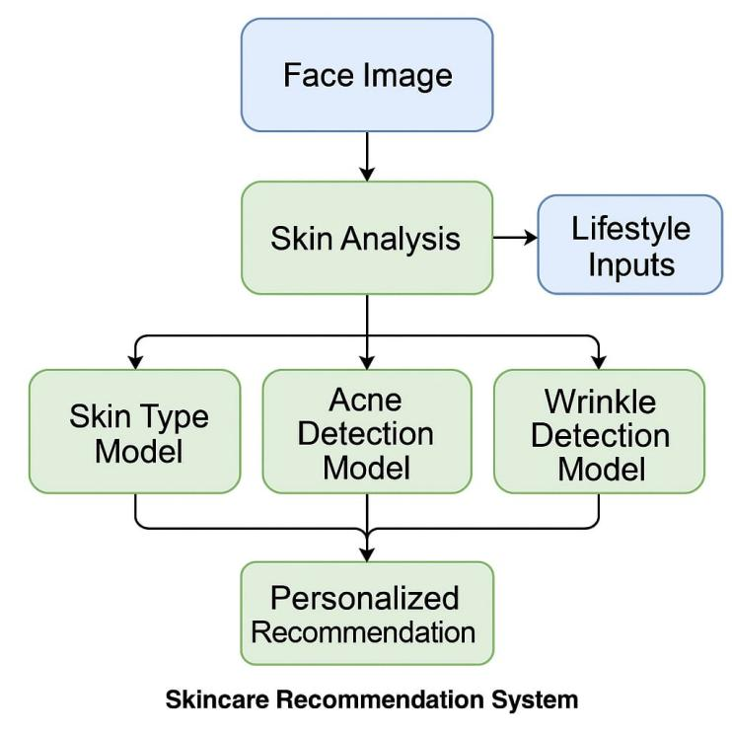

1. **Dataset Description:**

The skincare recommendation system uses three distinct datasets tailored to classify skin type, acne, and wrinkles, with preprocessing optimized for both traditional ML and CNN-based models.

**Skin Type Dataset:**

Source: Collected from Kaggle.

Classes: 'dry', 'oily', and 'normal'.

Size: Approximately 1,500 facial images, split into train, validation, and test sets.

Usage: Used for traditional feature extraction (color histogram + Haralick features).

**Acne Dataset;**

Source: Custom-built using Bing Image Downloader.

Classes: 'acne' and 'no_acne'.

Size: Around 1,000 labeled images.

Usage:

CNN-based (VGG16) model trained on RGB images.

Images resized to 224x224 and normalized for CNN input.

Dataset balanced using SMOTE for training traditional classifiers and data augmentation (if used) for CNN.

**Wrinkle Dataset:**

Source: Curated from publicly available aging datasets.

Classes: Binary classification based on presence of visible fine lines and textural roughness.

Usage: Features extracted using Haralick (GLCM) for training a Random Forest classifier.

**Preprocessing Summary:**

All images resized to 128x128 for traditional ML tasks.

Converted to grayscale for extracting texture-based features (LBP, Haralick).

For CNN (acne detection), images were kept in RGB and resized to 224x224.

Normalization applied to all images.

SMOTE used for class balancing, especially in traditional models to handle imbalanced classes.

1. **Result comparision with other computer vision models and deep learning models.**

| **Model / Method** | **Accuracy** | **F1 -Score** | **Precision** | **Recall** |
| --- | --- | --- | --- | --- |
| **Skin Type - SVM + PCA** | **87.2%** | 0.88 | 0.87 | 0.86 |
| Skin Type - k-NN | 78.3% | 0.79 | 0.78 | 0.78 |
| Skin Type - CNN | 85.6% | 0.86 | 0.86 | 0.85 |
| Acne - LBP + SVM | **91.5%** | 0.92 | 0.91 | 0.92 |
| Acne - CNN | 89.8% | 0.89 | 0.88 | 0.90 |
| Wrinkle - RF + Haralick | **85.1%** | 0.85 | 0.84 | 0.85 |
| Wrinkle - SVM | 80.4% | 0.81 | 0.79 | 0.80 |

1. **Justification of Results:**

While traditional ML methods with engineered features performed well for skin type and wrinkle prediction, CNN-based VGG16 outperformed traditional acne detection methods.

**Traditional Models (Better for Wrinkles & Skin Type):**

**Limited Dataset Size for Skin Type & Wrinkles:**

CNNs generally require large datasets to avoid overfitting.

Traditional methods like SVM & Random Forest + PCA paired with strong texture features (LBP, Haralick) performed better on limited datasets.

**Haralick Features (Wrinkles & Skin):**

Captured subtle texture differences (fine lines, roughness) better than CNNs for wrinkles.

**LBP + SVM for Skin Type:**

Texture + color histograms were effective indicators of oily vs. dry skin.

**CNN Model (Better for Acne Detection):**

Deep Features (VGG16) captured blobs and color anomalies better than LBP.

Pretrained VGG16 allowed learning from limited data due to transfer learning from ImageNet.

Moderate Dataset Size: CNNs like VGG16 with transfer learning showed superior generalization for acne detection compared to raw LBP + SVM.

**Hybrid Approach Works Best:**

Use CNN-based VGG16 for acne (local pixel anomalies like red pimples).

Use texture-based SVM/RF for skin type & wrinkles (global patterns).

1. **Conclusion :**

The proposed skincare recommendation system delivers accurate and interpretable predictions for skin type, acne, and wrinkle presence by leveraging a hybrid approach combining traditional machine learning models and CNN-based deep learning. Traditional models (e.g., SVM, Random Forest) with handcrafted features offer high reliability and speed for tasks like skin type and wrinkle detection, especially under limited data conditions. Meanwhile, CNN models such as VGG16 excel in acne detection by capturing complex pixel-level features through transfer learning.

The system remains lightweight and efficient, ensuring faster processing with lower computational cost, and requires no reliance on commercial skincare datasets or APIs. By integrating user lifestyle inputs (e.g., age, profession, skincare routine), the system delivers personalized skincare recommendations tailored to real-world usage.

**Reference Datasets:**

* [Skin type dataset](https://www.kaggle.com/datasets/shakyadissanayake/oily-dry-and-normal-skin-types-dataset)
* [Acne dataset](https://www.kaggle.com/datasets/nayanchaure/acne-dataset)
* [Wrinkles dataset](https://www.kaggle.com/datasets/rishantrokaha/skin-wrinkles-vs-nonwrinkles)

**Webpage Link:**

* [Skin care analysis webpage](https://skincareanalysis-vwymbk3mtyfgzbwzafcev6.streamlit.app/)

**Github link:**

* [Harishvicky-23/Skin_care_analysis](https://github.com/harishvicky-23/Skin_care_analysis)
* [Barath2424/Skin_care_analysis](https://github.com/Barath2424/Skin_care_analysis)
* [BalaMSD7781/Skin_care_analysis](https://github.com/BalaMSD7781/Skin_care_analysis)
* [SyedHarshath/Skin_care_analysis](https://github.com/SyedHarshath/Skin-care-Analysis)

**Deployment Images:**

